**CN LAB # 1**

**23K-0594 (SEC - 5F)**

**Task 1:**

**Ans)** ipconfig is used to find ip address of computer on windows

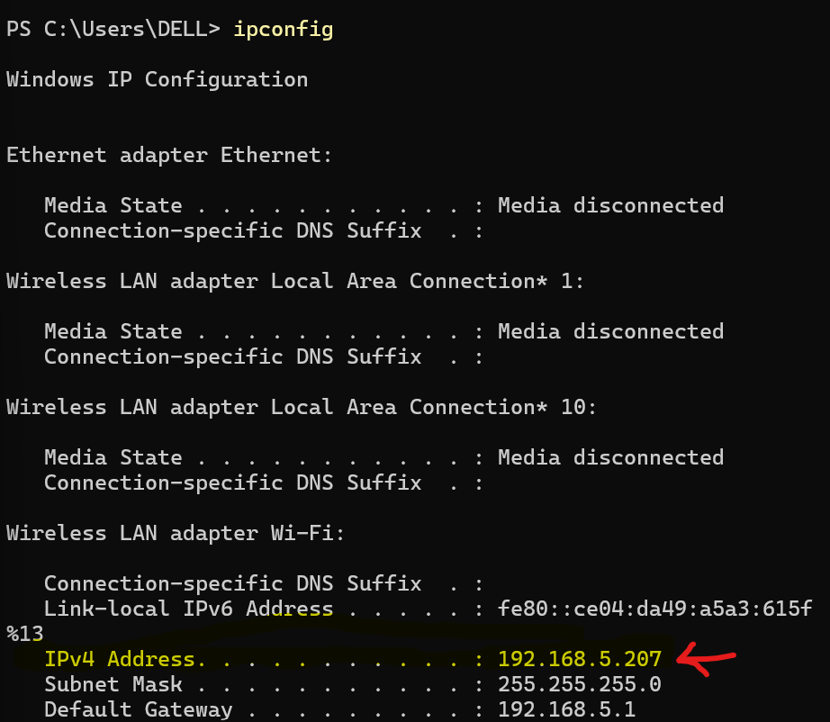

**Task2:**

**Ans)** ipconfig /all is used to find ip address, MAC address(physical address), Default gateway, DHCP status(yes, turned on)

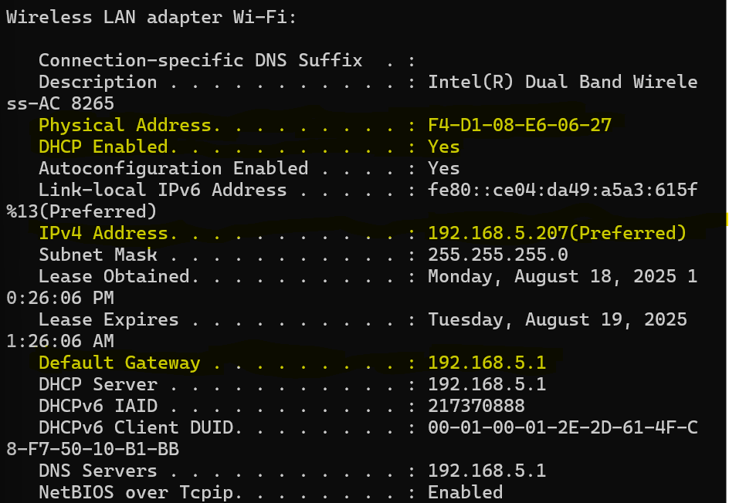

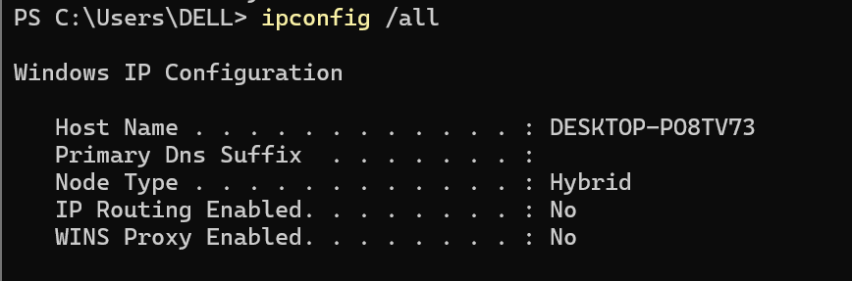

**Task 3:**

**Ans)** hostname gives name of the host.

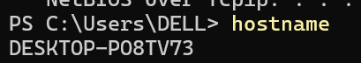

**Task 4:**

**Ans)** ping can be used with either the IP or the hostname to check whether a host has basic IP connectivity, if we cannot ping some host it is because either the host is down or the ICMP for the host is turned off.

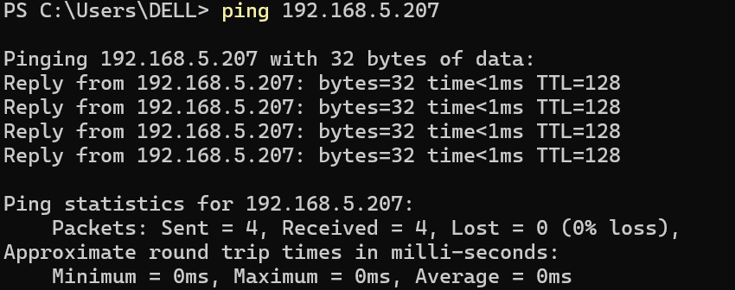

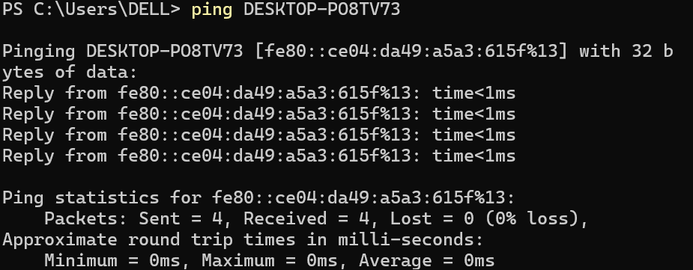

**Task 5:**

**Ans)** netstat is used to print status of network ports, routing tables and more.

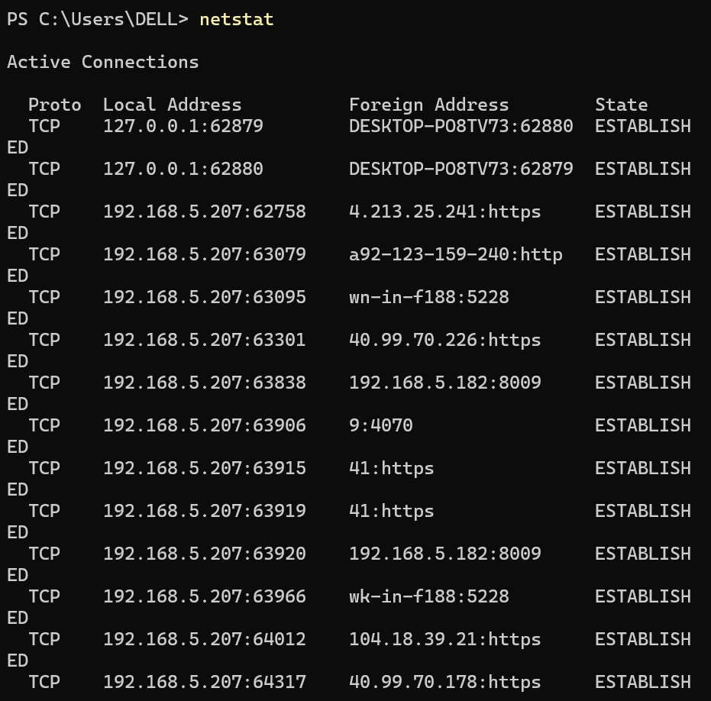

**Task 6:**

**Ans)** Total hops: 11, IP address: [142.250.202.228]

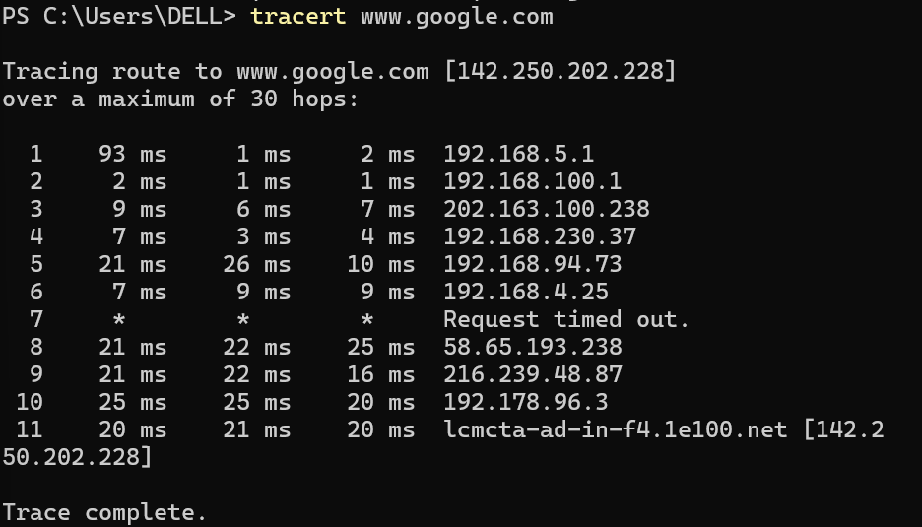

**Task 7:**

**Ans)** ping to 192.168.0.2 works but to blue machine fails because the hostname might not resolve to an IP address due to missing or incorrect name resolution (DNS/hosts file).

**Task 8:**

**Ans)** In a normal home installation, you use a **straight-through cable**. This is because you are usually connecting **different types of devices** (for example, your computer to a router or switch). A straight cable ensures proper communication between them.

**Task 9:**

**Ans)** Yes, however switch to switch connection should ideally be done with a crossover cable but a straight-through cable can still be used. As for router to PC since they are two different devices the ideal way to connect them is with a straight-through cable.

**Task 10:**

**Ans)** My home network is based on a **star topology**, where all devices are connected through a central device, the wireless router. The Internet connection is provided by an ISP (Internet Service Provider) through a fiber/cable line, which is connected to the router. The router functions as the gateway to the Internet, as well as a DHCP server that automatically assigns IP addresses to devices. The network consists of both **wired and wireless connections**. The wired connections includes a smart TV, connected to the router using straight-through cable and wireless connections are used by mobile phones and laptops.